West Hull Ladies
RRC

April Newsletter
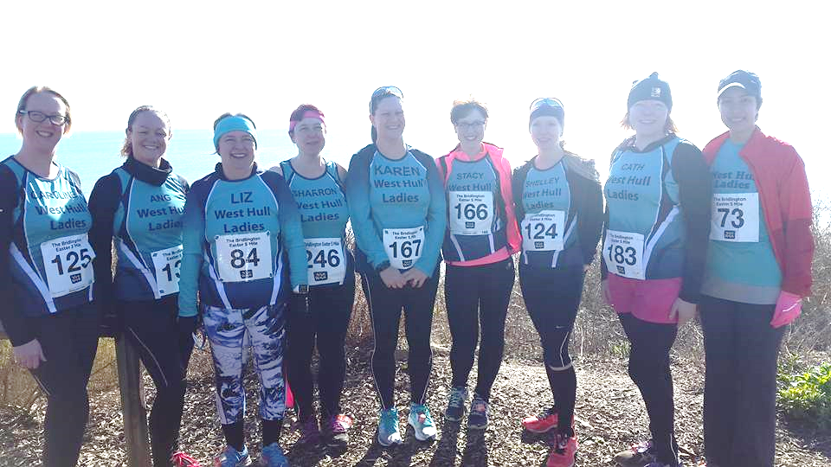
Bridlington 5

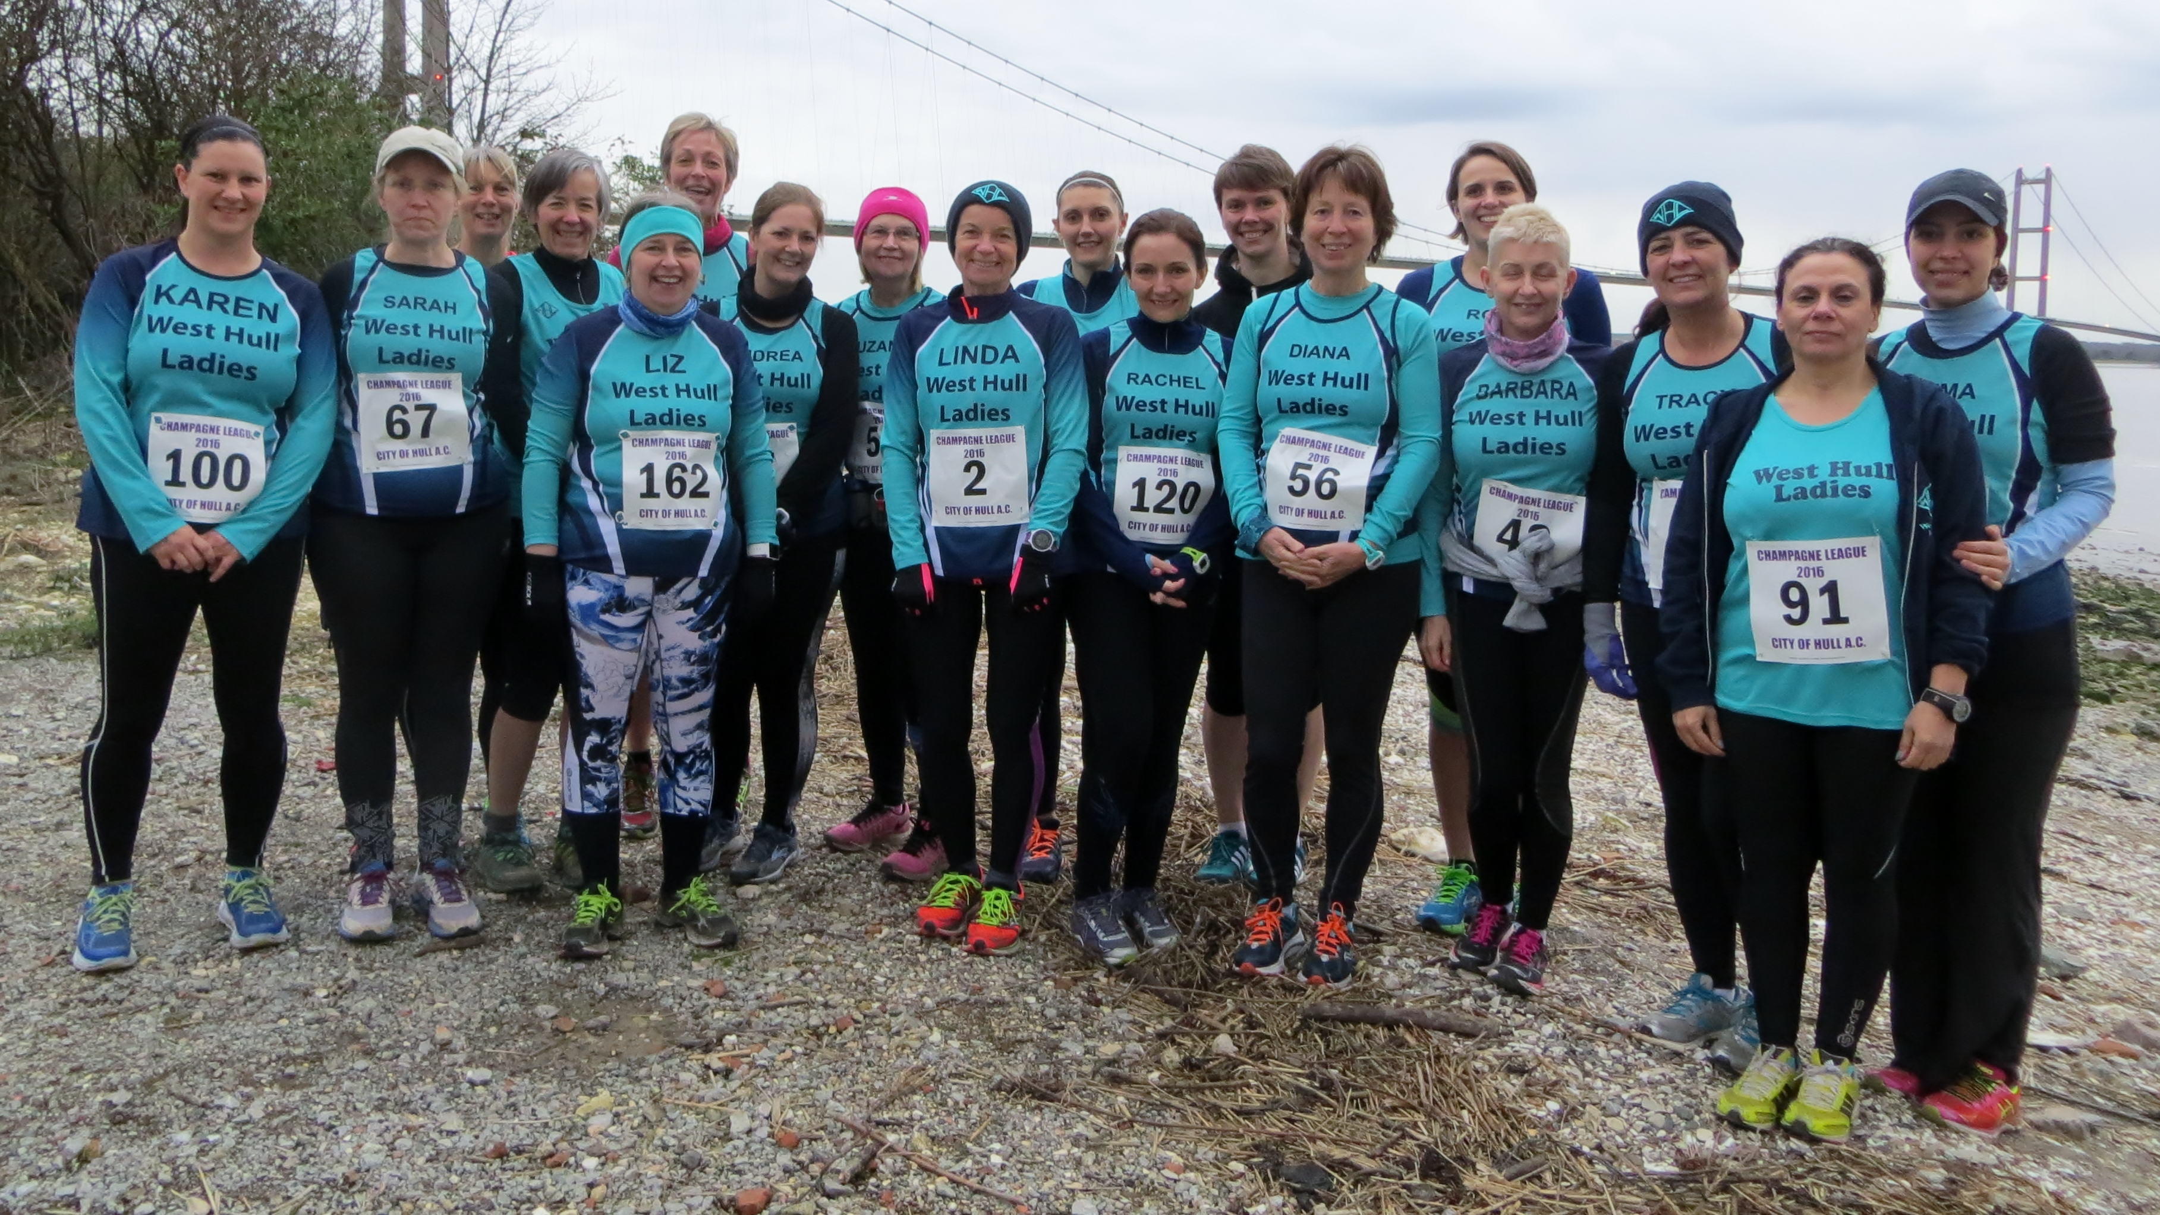Champagne League Race 1

West Hull Ladies
Committee Meeting Minutes

Monday 4th April 2016
Minutes

Apologies from Jill, Karen, Liz, Zoe, Annette

Present Sandra, Amanda, Linda, Jan, Maria, Anna, Jermaine

1. Minutes of previous minutes accepted as true record.
2. No matters arising.
3. Amanda informed the Committee of the results of the survey completed by members of 0-5k. It was decided that we would discuss how we could improve on the 0-5k steadier group if we were to run the same in 2017. In relation to the training for the steadier 0-5k group it was agreed that the Monday speed work sessions could be adapted so they could join in. On a Wednesday they would continue with 3-mile runs and this could increase once they were running 12-minute miles. Friday night sessions also could be adapted for all ladies to run. Action Amanda to email steady group to explain integration.
4. Jan spoke about the possibility of a weekend away at the Derwent water Hostel near Keswick. This was planned for the weekend (3-6th November) when the 10-mile race was on so members if they wanted could compete. Action Jan to circulate details to members.
5. Anna informed the committee that an email had been sent to members in relation to the Hull Marathon 2 person relay. Interest had been shown and 3 pairs had already got together to enter. 1 lady had shown interest in running the 4 person relay. More ladies needed.
6. This item in relation to the old vests was not discussed but earlier decision was to sell at £5 each.
7. A) Amanda asked for a volunteer to lead a recce of the Beverley 10k. Jan kindly offered. Action Jan to email details of date and time to members. 23rd April 0900 Beverley Westwood.
B) Linda stated they were still waiting for 11 membership forms and until they were received the ladies concerned could not be registered. This has implications, as they cannot run as a member of West Hull Ladies until registered. Action Amanda to send out email to the ladies concerned.

Meet a Member : Ros Barbour

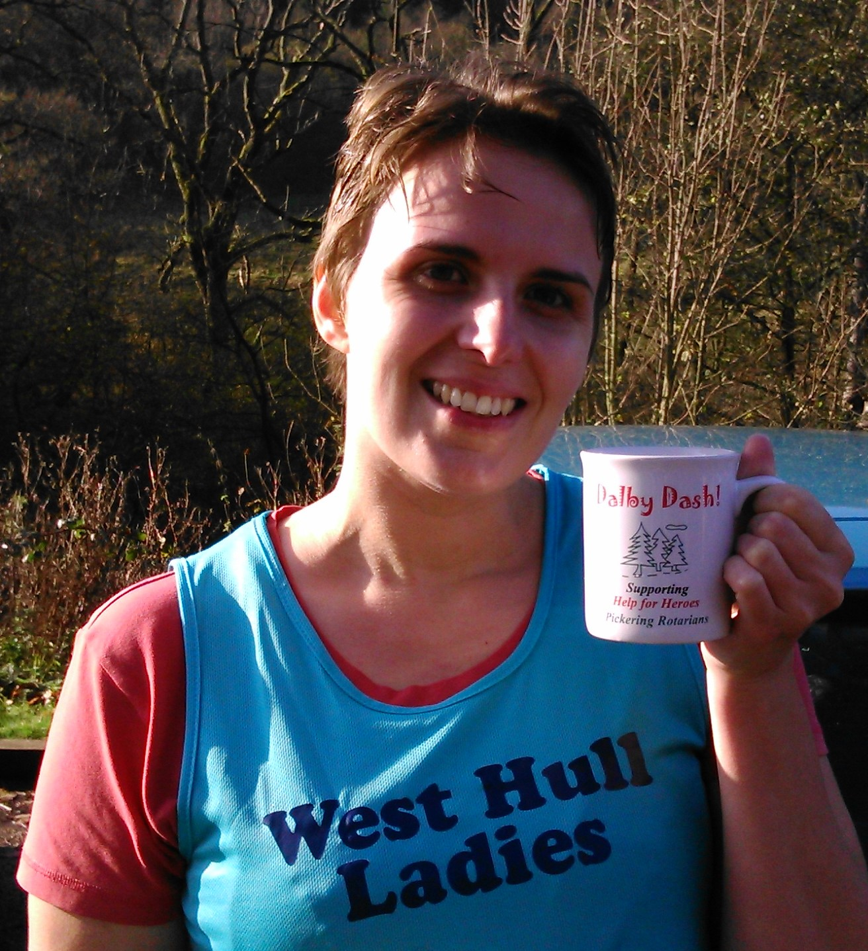
Age 32

Member of WHL since – August 2014, I joined the same day as Tracy..

What do you do when you’re not running? – (work/hobbies/family)
I’m a Communications Officer at Humberside Fire and Rescue Service. When I’m not at work or out running, I’m at the gym or doing yoga at home, as well as spending time with my boyfriend Bob, who’s been very understanding about my training schedule and occasional grumpiness after runs. Training for a marathon has also played havoc with my existing hobbies which include, screen printing, drawing and sewing that are linked to my arts training. Friends have even bought me a running pack sized sketchbook for me to take out on trail runs!

How long have you been running? -
On and off for 20 years and it’s only in the last 7 years that have I entered races. I ran at school (200m distance), when the thought of running a mile filled me with shock, 4 laps of the track seemed near impossible. Even back then I hated laps. My parents got me into mountain walking from the age of 10 and this led onto mountain climbing, and I would go to the Lakes or Scotland 3-4 times a year to climb. To keep fit for the mountains I used to run 2-3 miles 4 times a week and swam a lot as well. Running back then was a mix of running and walking, it was only in my early 20s that I realised I could run without stopping. I wavered from running in my mid to late teens and picked it up again whilst at university. In 2007 is when things got serious, I was working at Clough Road fire station and the operational trainers asked if I wanted to join them on a 3 mile run at lunch and I thought why not. To say it was a speed session was underestimating their competitiveness and we completed the 3 miles in 21 minutes. I was knackered, but I stuck with them and only collapsed from exhaustion when I got into the shower. It was also the first time I knew I could run without stopping!

Why did you start running? - My parents used to run so it always seemed normal to me and in recent years it’s been great for clearing my head after a busy day and a bit of me time.

Favourite distance – Half marathon, I’ve done more half marathons than any other distance and know how to pace myself to get around the course. Slowly getting there with marathons and I still don’t have a clue on how to pace myself from 5-10k. I’m hoping Champagne League will help me with this.

Favourite bit of running kit - Sports bra for avoiding two black eyes after a run and injinji toe socks for eliminating blisters.

Any injuries? - Apart from the occasional blister or broken toes from drunken adventures or climbing related (I’ve broken all but 3 toes, that includes my big toes, phew). I’ve only had one injury that was running related and it happened during last year’s Windermere marathon, it was so excruciating that I had to stop at 16 miles. During the race my lower legs felt as though they were being twisted similar to wringing out a cloth and resulted in blood pooling in the arches of my feet. This also caused nerve damage in my feet and I had a dull pins and needles sensation for 2 weeks. Following physio I discovered that my ankles don’t have a full range of flexibility, which means my walking and running style are not efficient and also being knocked kneed doesn’t help. I’ve seen an improvement since I’ve started my exercises to readdress this, it will take a long time and even though my times haven’t improved since then, I am finding that I recover quicker and my legs are stronger.

Running goals? – To become more efficient in my running style.

Proudest moment running related or otherwise – At the moment, completing my first marathon (Loch Ness marathon) a couple of years ago.

Best piece of advice you’ve received – Good runs come and go, but the bad runs show you how strong you really are.

Running alone or with friends? – A bit of both. I don’t run with music anymore as I found this distracting when I lived in London a couple of years ago. I enjoy the company of running with others but sometimes I want me time and enjoy being on my own.
What keeps you motivated? – I’m very competitive with myself and always set myself an annual goal, this year's is to embrace laps. Hoping the track sessions will help me before Thunder Run.

Meet a Member : Sian Alexander

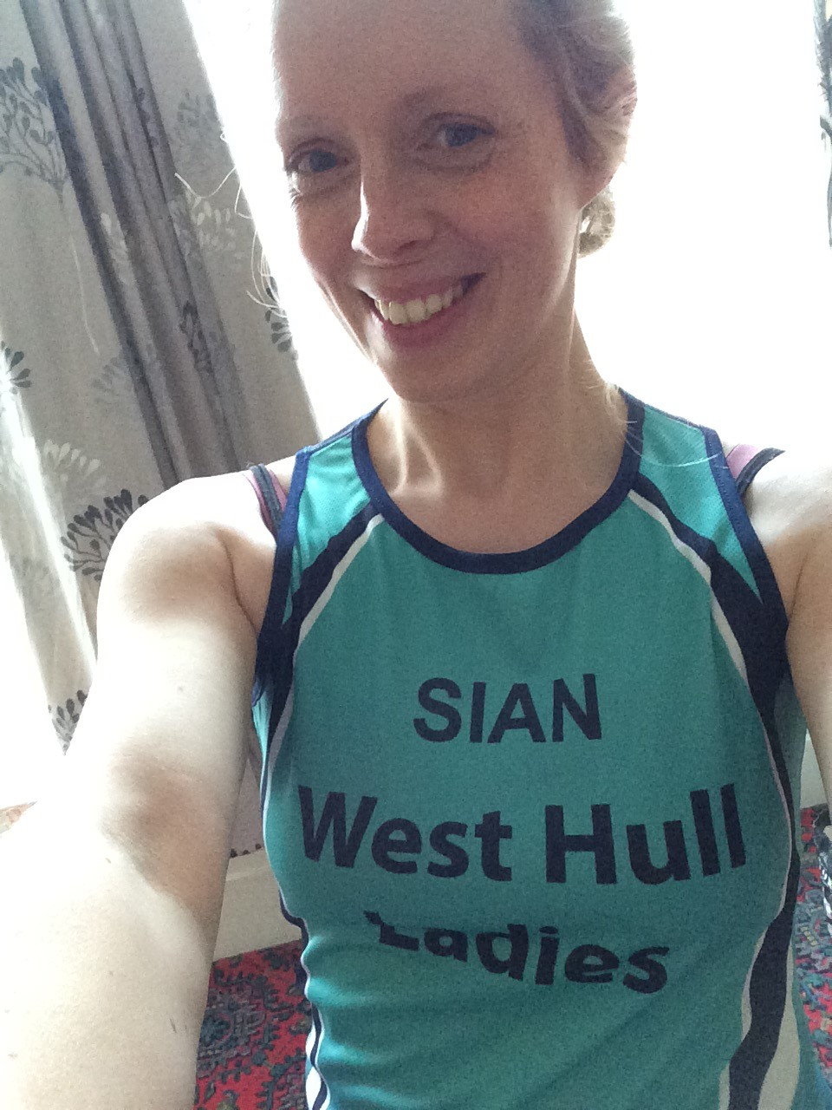
Age 36
Member of WHL since – January 2016
What do you do when you’re not running? – ( work/hobbies/family) Work at the University of Hull and have two young children - Jack aged 5 and Chloe 10 months. Apart from running, my hobbies are faffing about on social media, doing a bit of baking, occasional nights out drinking craft beer.
How long have you been running? - Since October 2015. I did the Couch to 5K app on my phone then managed my first Parkrun just before Christmas and was delighted to get 33:13.
Why did you start running? - To lose weight, have some 'me time' and do something new. I'd never been sporty before, in fact I actively avoided it as a teenager, but my husband is a runner (with City of Hull) and I saw the tremendous physical and mental health benefits.
Favourite distance – I'm hoping it's going to be 10k as I'm doing my first 10k soon! (Beverley in early May)
Favourite bit of running kit- Aldi compression top
Any injuries? Niggly piriformis and IT band. Flares up when I forget to do my exercises - which is often.
Running goals? I've only been running for six months so still getting used to it all. I guess just being able to do 10k in a reasonable time.
Proudest moment running related or otherwise – Getting a sub-25 minute Parkrun. I was aiming for anything under 27 minutes and had no idea just how much quicker I was until my time came through later that day. I was in tears. Oh, and giving birth and getting married. They were pretty good too.
Best piece of advice you’ve received - After having a crappy run recently, my fellow WHLs gave me tonnes of support on FB and reminded me that even if you have a rubbish run, it's better than no run at all.
Running alone or with friends? With friends.
What keeps you motivated? In the event of a zombie apocalypse, we runners will be at an advantage :-)

Clumber Park Duathlon : Amanda
Qualifying to Represent GB at the Duathlon Worlds Championships

I think I should start with how I got to the point of being on the front line of this duathlon with the intention of qualifying to represent Great Britain in the Duathlon World Championships. It still sounds ridiculous that I should be considering it.
I competed in the same Clumber Park Duathlon in 2014. I came 1st in my age group and was amazed to find that if I had registered, I would have qualified for the Worlds. Madness! 2015 wasn’t my best year and as the Worlds were in Australia it was out of the question. However, at the end of last year my husband (Neil) pointed out that this year they would be in Spain. I checked out the winning times from 2014 & 2015 Worlds and found I was 9 minutes faster than the winning time in 2014 but 6 minutes slower than the winning time in 2015. This still gave me confidence that not only could I qualify I could put in a competitive performance.
The next obstacle was the cost – should I really be considering spending so much money on one event? 200 Euros to enter the event, £160 for the team kit (compulsory), £450 for the team hotel (equivalent of the Olympic Village), around £800 travel and it kept increasing. I decided to try to get some sponsorship but the first step was to qualify. Even that is not cheap £50 for the annual British Triathlon Federation membership, £45 for the event, £10 to register your intent to qualify, £7 parking, travel. Good grief! Running is cheap, cycling is cheap (apart from buying a bike) put the two together and it’s a money sink! However, this was for a once in a life time experience.
So, I had to qualify and come 1st in my age group (top 4 qualify). Some people go for the experience, I want both the experience and to think that I may have a chance of being ‘up’ there . Without 1st place I was not going. Four other ladies in my category had registered their intention to qualify so I expected strong competition. Was I ready? My running was slower than two years ago but I had been training doing ‘brick sessions’ 20+ miles on the bike then run 5K. I felt I was as prepared as I could be. Well sort of -a virus hit me 2 weeks before the event and pretty much floored me for 10 days.
The day came with a very early start leaving Hull 6:30am. Neil drove and we arrived with 1hr 15mins to sort out – which wasn’t enough! Registered, loo, took ages getting numbers sorted- one on bike; two on me; one on helmet and chip on ankle. Next bike to transition and laying out kit neatly, checking out the run/bike exits and entries. Loo again. Barely a warm up. Still needed loo but we were off.
People are set off in waves based on age and gender with a minute between. There were people doing both the sprint and the standard event. About 850 in total. It was really difficult to know where I was in the run, lots of ladies ahead but they might be sprinters. Transition, what a muppet, stuff helmet on my head, a pointy thing which I had been given a week ago. It doesn’t have a cradle and I shoved it on backwards!!!! Ran with my bike, got shouted at, laid down bike, removed helmet swivelled, helmet on and off again. Not the best transition. Then the cycling was a nightmare. The drafting rule says once you are within 10 metres of someone you have 25 seconds to pass and the official motorbikes were everywhere, if you draft 2 mins is added to your time. I was constantly coming up on cyclists, not sure of 10 metres distance, impossible to time 25 seconds. So passed, then more bikes. Then a lady kept passing me and slowing down and I had to pass her (4 times). It was really stressful and I did not once get into a rhythm. I really was wondering if it was worth it. Transition 2 went OK (can’t go wrong taking the helmet off). Then I was off for the 5K run, tough but at least I didn’t have to worry about drafting!
It was all over. I collected my bike and kit and found Neil. He had picked up my result slip which gave my time, 2hrs 23mins, but no indication of position. The time was the same as 2014 so I was happy with it as I thought I might be slower but, was I first? After packing the bike back in the car and eating lunch (pie!) we went down to find out the results. Positions still not listed but Neil decided to print off all the slips from my group (there were only 7 of us). Wow, not only was I first FV55 I had beaten the 2nd in my age group by over 13 minutes! Money permitting I was going to the Worlds. Woo Hoo.

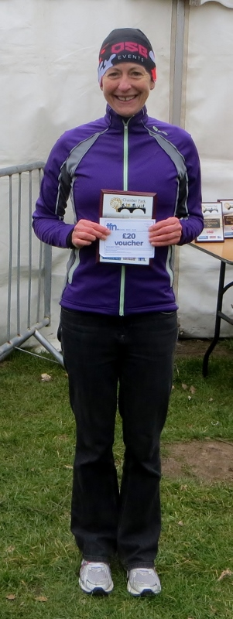
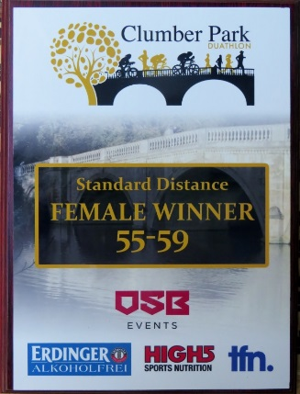

10K 45:45
T1 1:59
Bike 70:56
T2 1:34
5K 23:25

Total 2hrs 23mins 37secs

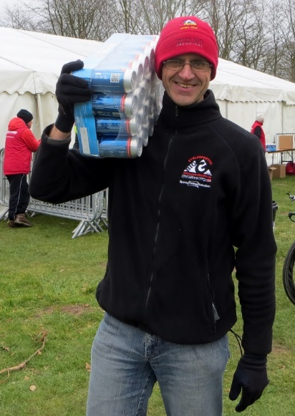

Neil carries my prize of 24 cans of Erdinger alcohol free beer, isotonic recovery drink.
Not sure how I would have carried that back to the car – it was so heavy!

Money permitting? It’s taken some doing, I have been turned down twice but just this week it all came together and I have secured some sponsorship, enough to ensure I am going to the Worlds. Training is even more serious now, I cannot let my sponsors down.

East Hull 20 : Lynne

I’d quite enjoyed training for this as the weather had been reasonable this year and after stuffing myself full of food and wine on holiday in February, what better way to start working it off by long early morning weekend runs. Originally Ros had put the idea into my head of getting in under three hours so I trained with that mind set knowing that last time I did this race in 2013, I didn’t train as such and just relied on what I’d done for the Rudolph Romp and came panting in at a disappointing 3:27. I also realised close to the date that both Sara Ellis and Rach Laughton were running albeit Rach had to pull out. But I knew long distance wise we could match speed and time as we had ran Rudolph together previously and done many a long haul recce. My plan was to hopefully run with these two although they had been doing a lot of speed training so I thought if I kept reasonably close to them then I’d get a good time without any repercussions.

On the day it was beautiful weather, fairly mild with a good bit of sun, Debbie, Rach L, Karen & Rach Anderson I saw at the start cheering us on and Rach L got a great start photo of Sara and I. There was no timing chip so Rach L ordered us to get to the front and so we did, by then my Garmin had a hissy fit and under protest wouldn’t work, kept telling me it was in ‘indoor mode’ so as soon as we set off I had to rely on Sara for pace and time until mine worked correctly. I was hoping to stick to 8:30 minute miles but we were going faster than that and I was convinced that I’d end up flagging so once my Garmin behaved, I told Sara I was dropping back slightly but actually we ended up mostly running together and chatting and moaning and laughing and tutting our way round. We also spent some time chatting with other runners and swapping stories, picked up water at every stop and jelly babies so very well marshalled as usual. Calves and shins started to flag a little towards mile 16 and then we also got really quiet between us and so concentrated on the last four miles digging deep as that rail track can be a bit of a bind but for once there wasn’t really w wind but we did get rain which was very refreshing. We also knew we had those kerbs to deal with round Howdale Road and that hill at the end. There was a chap really breathing down our necks as we approached the last two miles and in fact he coughed so loudly I nearly jumped out of my skin but I think that spurred me on that someone was chasing me down. Once I saw the hill I automatically speeded up, I think I could smell the finish line, I shouted to Sara but she just spurred me on so I went for it and even managed sort of a sprint finish.

I was really pleased to have finished with such a good time (2:54) and was even more pleased that during marathon training last year my hip gave me so many problems, well I didn’t even feel a niggle from it during this run or any of the training. It was a great reception from the West Hull Supporters who had turned out. It was fantastic to get support around the route from so many people including Sandra, Rach, Debbie and Sally and I saw Joanna Plumb near the end right at the top of the hill, sorry if I forgot anyone.

A special thanks to Sara though, she made a great running partner and we all received an amazing trophy vest (last time I got a white towel!!) and the usual buffet at the end was just superb, I had four pieces of cake. I’d do that race again next year I think.
Lynne

My First Park Run: Carol Holmes

“If at first you don’t succeed”………try a different approach, so I did! As some of you are aware I have tried the 0 – 5K training a few times now, but I either get injured or demoralised or both, and after last year’s unsuccessful attempt I started believing that running was just not for me, that I was the wrong size, shape and definitely the wrong weight, so I decided to cycle instead. I joined the Sunday Girls Cycling Club and gradually built up my confidence and distance. Ann suggested I give myself a goal to train towards, “I don’t do goals,” I said, “what if I’m unsuccessful like with my running?”

Not to be put off, Ann started looking at different sportives that could be possible, and after reading about the Selby 3 Swans Sportive (finding out it was flat) I decided to go for it, and yes I did it, 66 miles! It felt really good to achieve a goal. With this in mind and with much encouragement from Ann, I decided to try running again with the Parkrun as my goal - I would be so happy to run Parkrun without having to walk every few minutes!

After the first week of training I realised if I didn’t change something I would once again be unsuccessful - I couldn’t keep up with the pace and with the fast progression, so I mentioned to Sandra that I could do with stretching the course out a bit in order to make the progression slower and more manageable, and she said, “Ok, lets do it!” And so we offered the suggestion up to others that wanted to take it slower, and I think you all know the happy ending, my little steady group and me did it!
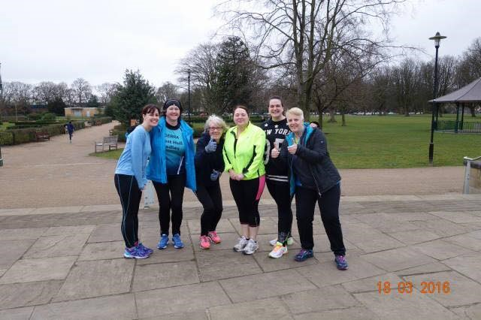

I ran 5K without stopping! I really find it hard to put into words what it means to me, but I know that I couldn’t have done it without the encouragement of Ann and Sandra and all of the lovely women in this marvellous club, thank you all so much.

I dig in and give it my all and I know that all of you respect my efforts rather than comparing and judging. All of the time that I am running I have nagging thoughts that tell me to give up - I’m too fat and old for this, but I battle these thoughts and I’m definitely winning!

I’m a runner, I’ve always been a runner, when I was younger I ran for my county, but that was sprinting, distance is something I’ve always struggled with, and possibly always will, but one thing’s for sure, I won’t give up!

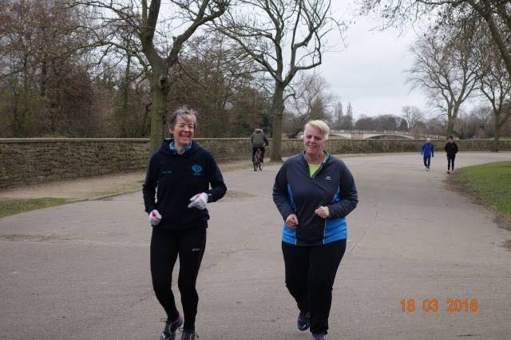
Baildon Boundary Way: Amanda

I took a bit of persuading to say yes to this run as it’s a bit of a drive away and not duathlon training (I’m a bit run-cycle focussed at the moment) but Becky, my Bingley Harrier fell running friend, was keen and I could stay at her place. So I booked and continued training for the Worlds which did not involve much in the way of long or off-road runs. However, the Sunday before I ran a hilly 10 mile from Brantingham – the start and end of my BBW training.

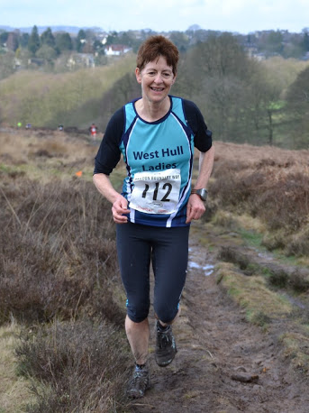

BBW is an off-road half marathon. It’s not a fell race although a bit of fell is covered. However, a large proportion of the run is along flat tracks and canal embankments. Between the flat sections you happen to have some noticable hill climbs and over the course of the 13.56miles you climb over 1,100ft (340m). And there was oodles of mud too. Did you notice the distance? You get 0.4 miles extra at no charge.

I must admit to not really knowing quite where I was so my route description is dodgy, however, the route starts on a track which takes you over a hill then drops to the Aire Valley where you run on various terrain which includes some on a canal tow path and at some point we go through civilisation which I think is Shipley, but not for too long. Then a climb before a drop through some lovely woods – at least would be lovely but for the ankle deep mud
We then pick up a path along the River Aire which is muddy too, then onto canal tow path for quite some time. Towards 9 miles I was slowing so decided to eat my gel, slowed a bit more to allow for digestion then picked up again. At 10 miles the climbing begins in earnest and over the next 3.5 miles we head all the way out of the Aire valley bottom to the top of Baildon Moor.

Caught me walking - nearly at the top
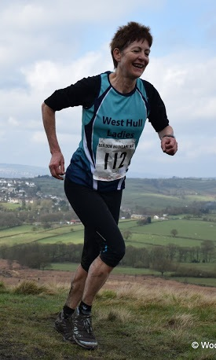
Camera shames me into running

Overall I was really pleased that I felt strong throughout and could even put in a fastish run over the last section where it flattened out. A small sting in the tail is the end where you run round the field which is a bit nobbly with deepish grass and as you are pushing for the finish it feels tough.
I finished in a noisy fashion gasping through the finishing funnel, at the end of which I was really excited to get a spot prize. First time for me. I tottered around a bit, collected my long sleeved T shirt whilst they still had XS left, then into the hall to collect a spot prize.

There was a lot to choose from. Chocolates and bottles of alcohol featured well but I spotted a pink, light running jacket. Wow, what a lovely chance prize.

I had been hoping for under two hours and that was assuming a half marathon distance so I was really pleased to do it in 1hr 57mins 44secs (which included the extra ‘free of charge’ 0.4mile) and even more pleased to get first FV55.
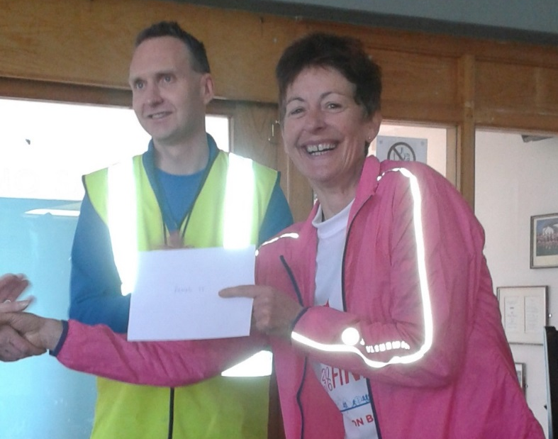

Do I recommend it? YES because of the beautiful terrain NO if you don’t like mud or hills. YES because the organisation was excellent. The marshals were everywhere you needed them and very encouraging. Throughout woods, fields, moors there were flags and bright bits of plastic tied to trees to guide you. And for when it is all over, the headquarters is a rugby club selling soup, bacon butties, cake, tea etc. A nice touch was two separate organisers approaching after to ask if there was anything they could do to improve on things. All I could think of was ask for less rain in the run up to the race!

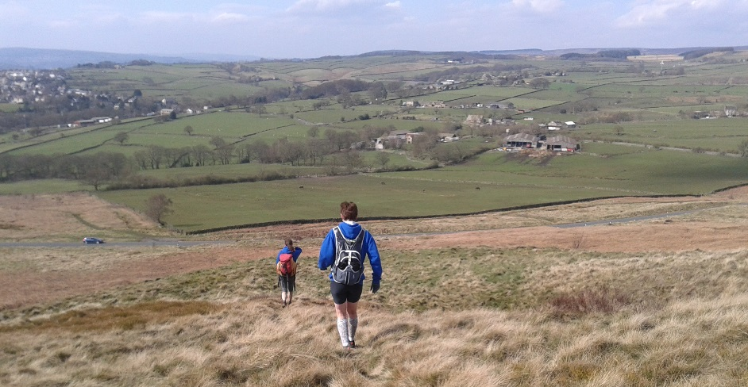

After prize giving I walked with Bingley Harriers Becky and Lesley the two miles back to Becky’s house, the views were wonderful and it was great way to loosen the muscles.

Presentation Evening

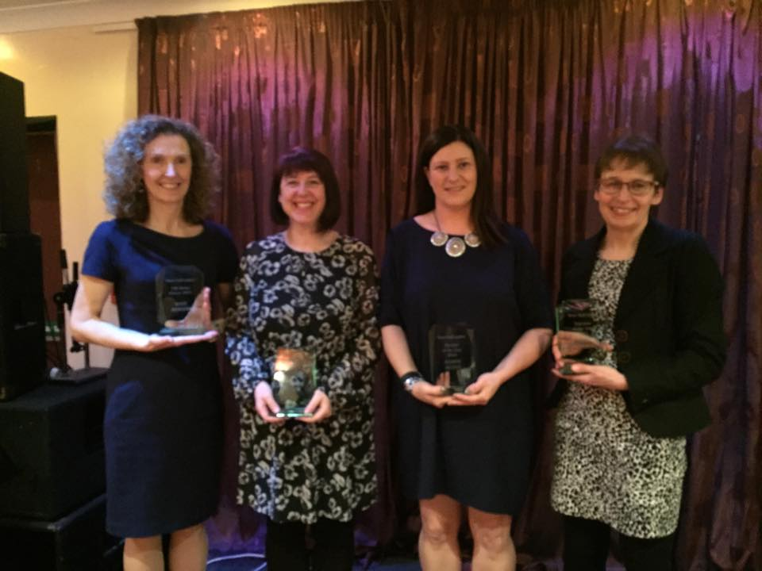

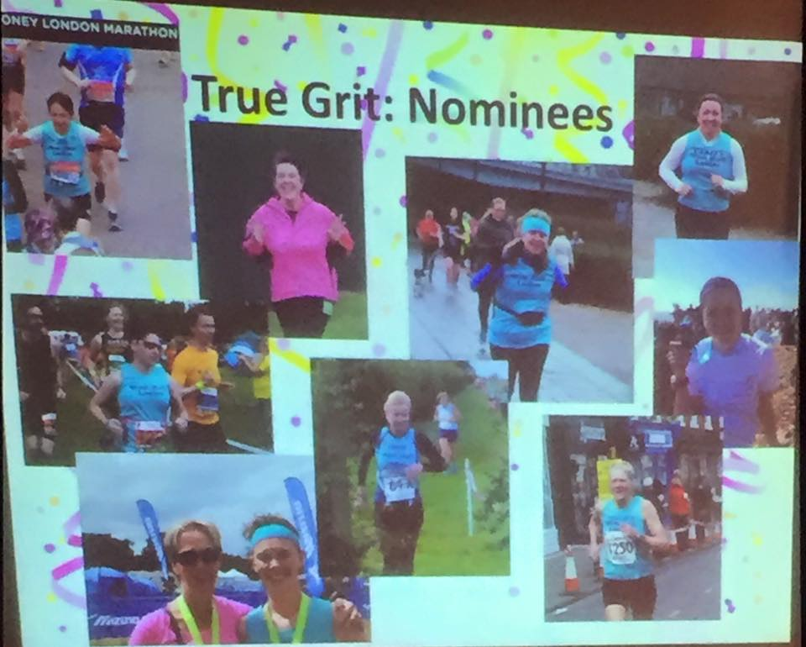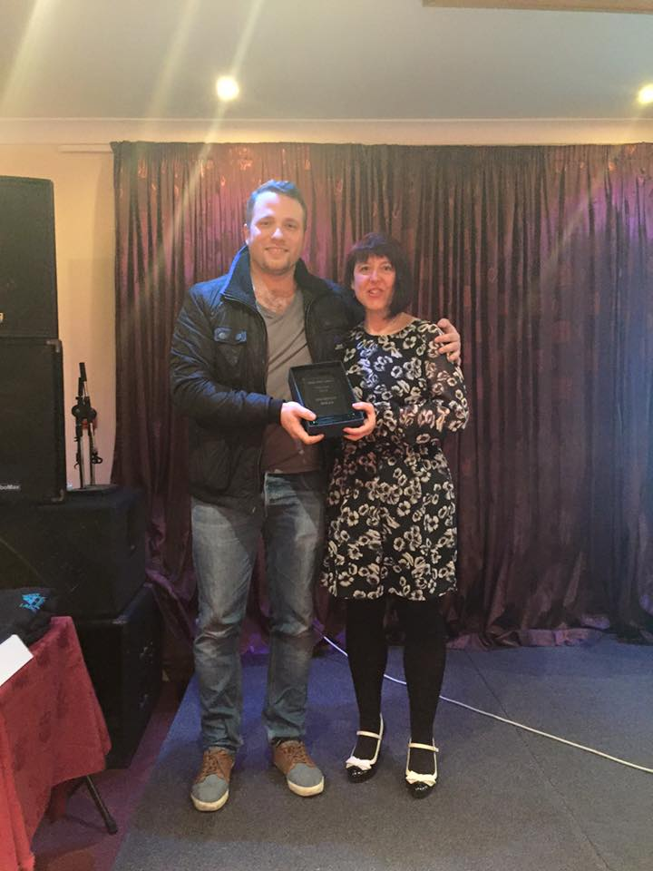
True Grit Award – Sharron Wiley
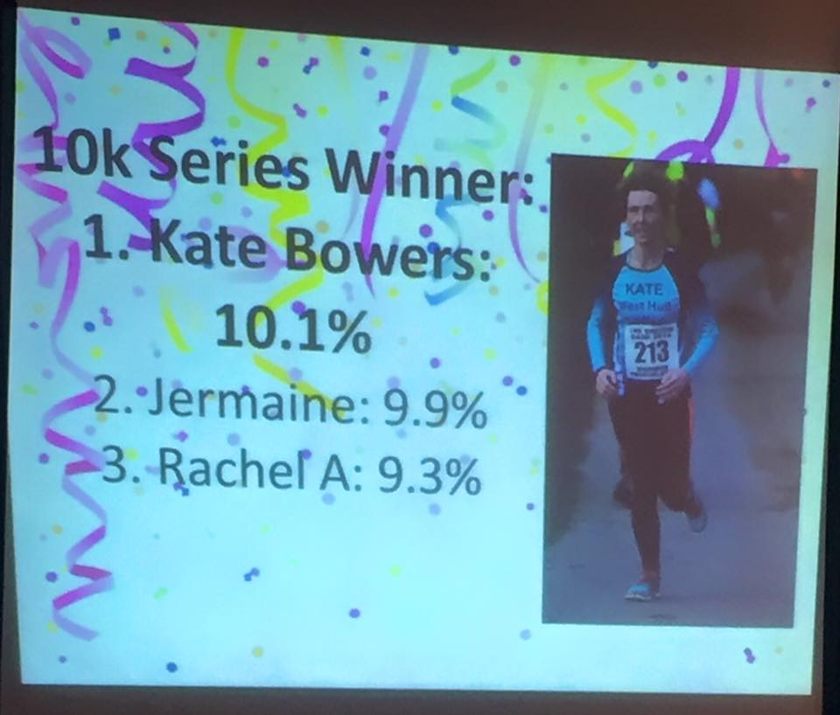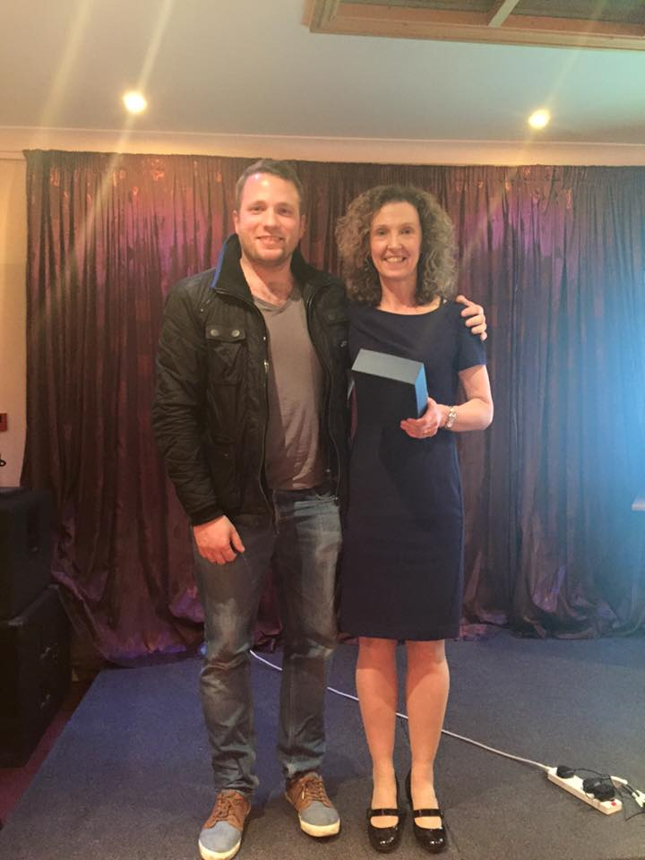10 k 10K Series- Kate Bowers

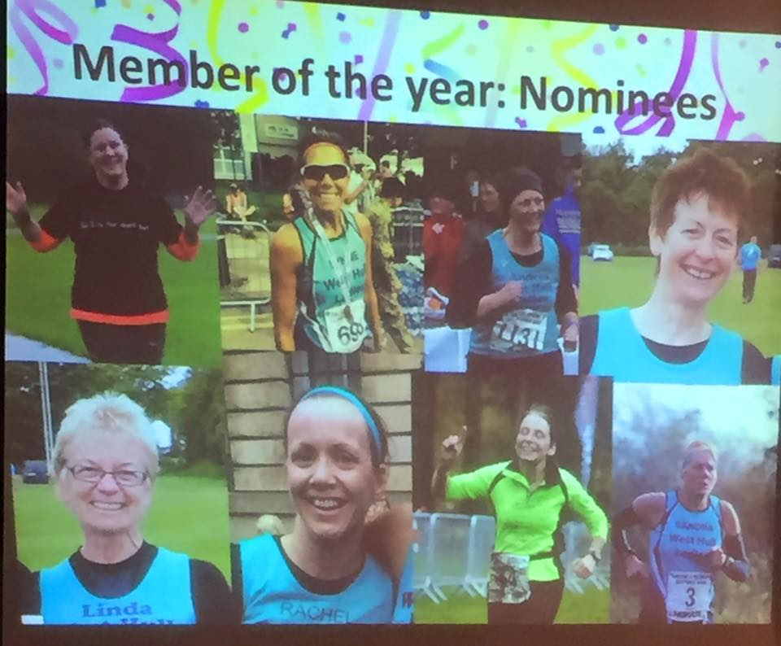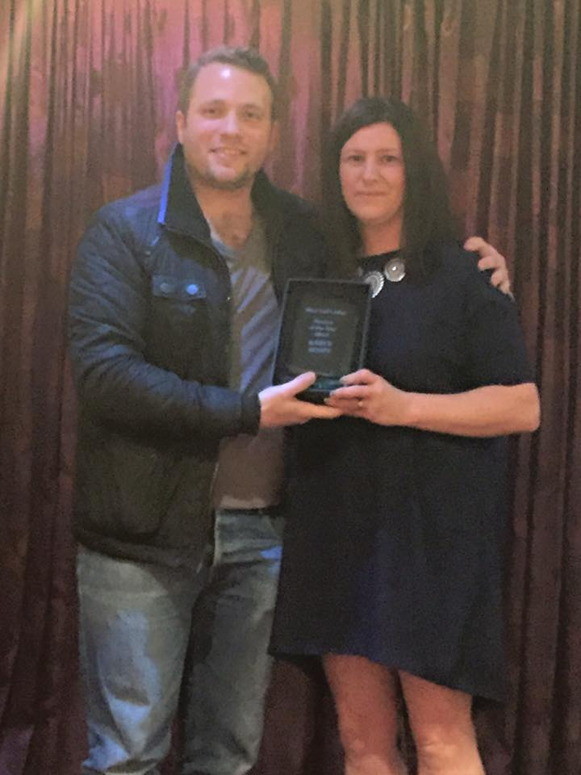
Member of the Year- Karen Scott
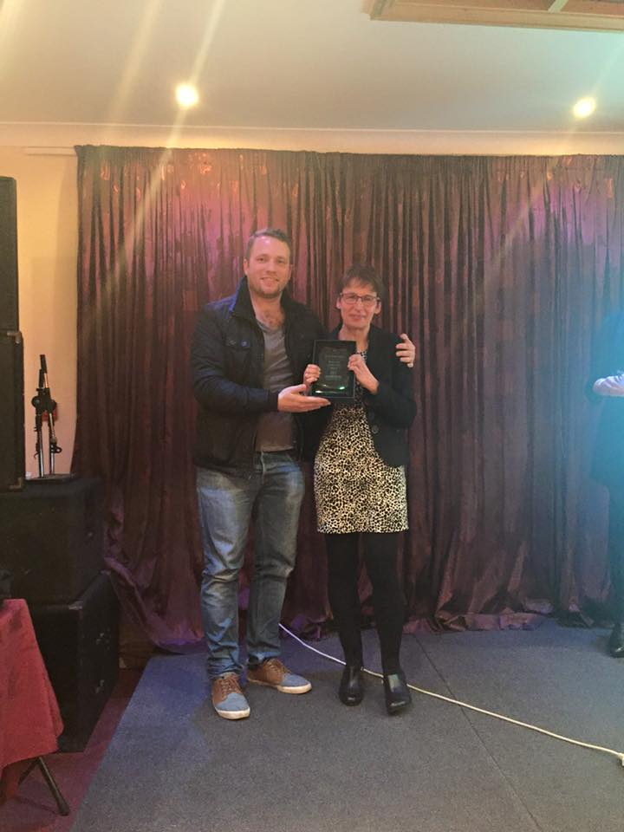
Most improved member – Jill Jameson

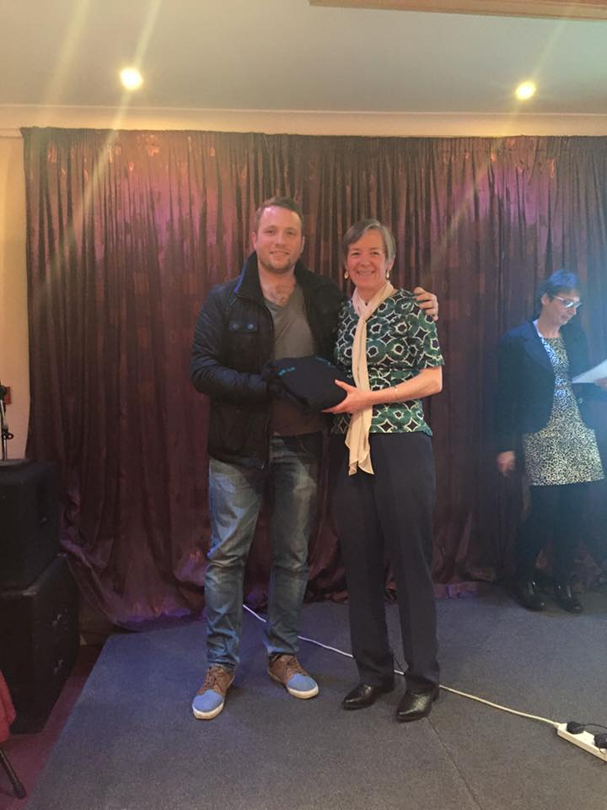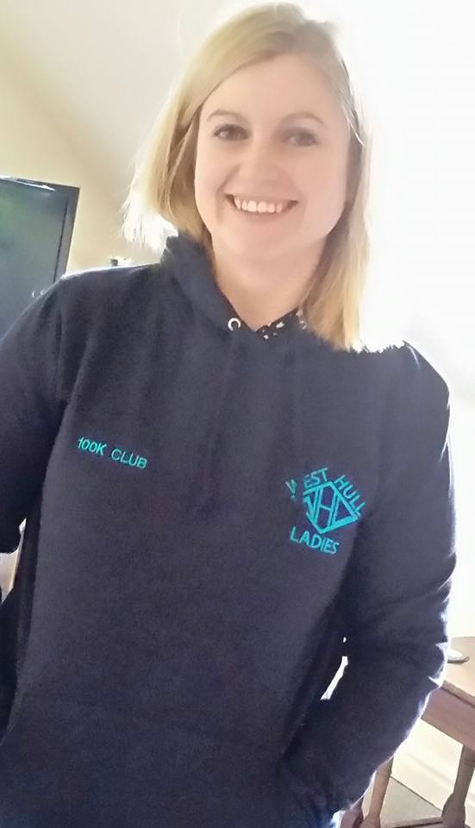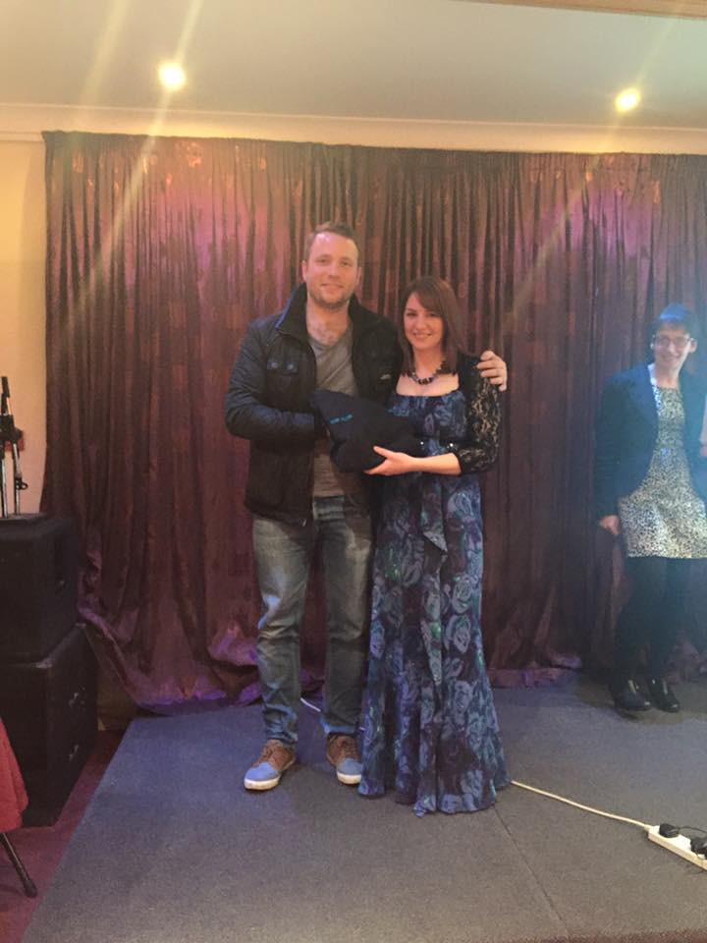
100K Club members
Ann Holmes, Sally Widdowson , Zoe Jameson
Recipes

Here is a recipe I tried from Runner's World, the bars are really tasty and don't need cooking. I'm sure you could put a layer of melted chocolate on the top too if you wanted more of a treat!
Shelly
Peanut butter and cranberry energy bars
Ingredients:
200g dates, pitted
100g dried cranberries
4 tbsp. peanut butter (crunchy or smooth)
75g whole, un-blanched almonds (I'm sure you can substitute these for your favourite nuts though)
25g oats
Method:
1. Soak the dates in 150ml warm water for 15 minutes, then drain.
2. Place all the ingredients in a food processor and blend until combined.
3. Spoon the mixture into a lined square baking tray and press down firmly
4. Place in the fridge or freezer for an hour to set then cut into eight bars.
5. Store in the fridge.
Nutrition:
per 60g serving: 251 calories, 33.3g carbohydrate (28.7g of which sugars), 4.6g fibre, 6.8g protein, 10g fat (1.1g of which saturates)

Fundraising News

My friend and work colleague Katy and I are going to be running the London Marathon for the charity KIDS who provide a wide range of support and services for disabled children, young people and their families as part of the Armitage Thanks fund raising events.

In addition, four weeks after this we are also going to be doing the Three Yorkshire Peaks – again for Armitage Thanks – there’s clearly no stopping us!

Armitage Thanks is an initiative set up by Ideal Standard, who we both work for, to celebrate the 200th anniversary of Armitage Shanks in 2017 by raising £200,000 for charities, both national and those more local to Hull and Armitage where our offices and factories are based.

Since we chose KIDS as a charity we have had a number of people locally tell us how they have direct dealings with and help from KIDS so it’s nice to know that the money raised is going to good use.

We have almost £1,000 sponsorship already but are a little way off our target so any donations are gratefully received!

The link to our fund raising page is as follows –
http://uk.virginmoneygiving.com/KatyRachel
Thanks!! Rachel W

Two more of our London Marathon runners are raising money for excellent causes:

Linda is supporting Boxer Friends Spain, a charity that provide care for Boxers:
www.gogetfunding.com/boxer-friends-spain.

Fatma is running for the charity Refuge, supporting those suffering from domestic violence:
https://www.justgiving.com/runningturks

2016 RACE DIARY

Free 5K time trial every Saturday 9am:
Hull Parkrun Peter Pan Parkrun Humber Bridge parkrun

Double check dates, times and entry fees with the official website or the entry form. Zx Website contains all the links to the races: http://westhullladies.org.uk/races.htm

 | Date/Time | Event | Fee | Entry forms | Online entry
Apr  2016 | 3rd/10:00 | Reading Half Marathon | £35 UKA/£41 | Online entries only | Online entry
 | 10th/TBC | Jane Tomlinson Yorkshire Half Marathon, Sheffield | £30.10 UKA/£32.10 | Online entries only | Online entry
 | 10th/TBC | Greater Manchester Marathon | £58 UKA/£60 | Online entries only | Online entry
 | 10th/11:00 | Hornsea Third Marathon | £12 UKA/£14 | Entry Form | Online entry
 | ch17th/11:00 | Jane Tomlinson City of Lincoln 10K | £24.75 UKA/£26.89 | Online entries only | Online entry
 | 17th/11:00 | Burton Pidsea 10K | £11 UKA/£13 | Online entries only | Online entry
 | 24th/TBC | Virgin Money London Marathon | Race Full | Race Full | Race Full
May  2016 | 2nd/10:30 | East Leeds Trail 10K | £12 UKA/£14 | Online entries only | Online entry
 | 3rd/19:15 | EHH Summer League  Sproatley 6 Miles | £6 UKA/£8 | Enter on the day | Enter on day
 | 8th/09:30 | Jane Tomlinson Leeds Half Marathon | £30.10 UKA/£32.10 | Online entries only | Online entry
 | 8th/11:15 | Beverley 10K | £13 UKA/£15 | Race Full | Race Full
 | 15th/09:00 | North Lincolnshire Half Marathon | £26 UKA/£28 | Online entries only | Online entry
 | 15th/TBC | Jane Tomlinson Nottingham 10K | £25.82 UKA/£27.96 | Online entries only | Online entry
 | 15th/10:00 | Derwent Dash 10K | £14 UKA/£16 | Online entries only | Online entry
 | 17th/19:15 | EHH Summer League  East Park 4M | £6 UKA/£8 | Enter on the day | Enter on day
 | 31st 19:15 | EHH Summer League  Leven 10K | £6 UKA/£8 | Enter on the day | Enter on day

NOTE: Club Vests must be worn at any races you enter
under the West Hull Ladies running club name.

Kit Order Form

NEW STYLE VESTS and HOODIES are purchased direct from www.pbteamwear.co.uk
On website: click on Clubs, Athletics Club, West Hull Ladies RC
Pick your size, name you wish to have on the front and follow payment instructions

For all other purchases use this form.

FORENAME ___________________________________
SURNAME ___________________________________

ORDER - tick what you require and circle your size Price
- OLD STYLE VEST SIZE 10 12 14 16 £15.00 £5.00 (useful for training)
- LONG SLEEVED SIZE 12 14 £18.50 £10.00 (useful for training)

- BEANIE HAT £6.50
- PINLESS WHL NUMBER FASTENERS (set of 4) £3.00

DATE Ordered _______________
AMOUNT PAID _______________

Please transfer payments online with your name and marked as ‘Kit’ to:
Account: 63762742 Sort Code: 20 43 49

Or cheque payable to ‘West Hull Ladies RRC’, and write your name and ‘Kit’ on the back and give to Club Treasurer Linda Dodsworth, 110 The Stray, South Cave, E Yorkshire. HU15 2AL

Sign on receipt of goods _________________________________
DATE _______________

Please complete this form and email to diazmaria@btinternet.com
Thanks.
Maria Kit Officer

